Final Project Report

Online Handmade Crafts Store



Project Supervisor

Sohail Amir

Submitted By

F24PROJECT8A51B

Alia Bibi BC210415321

Software Projects & Research Section,
Department of Computer Sciences,
Virtual University of Pakistan


CERTIFICATE

This is to certify that Alia Bibi(BC210415321), have worked on and completed their Software Project at Software & Research Projects Section, Department of Computer Sciences, Virtual University of Pakistan in partial fulfillment of the requirement for the degree of BS in Computer Sciences under my guidance and supervision.

In our opinion, it is satisfactory and up to the mark and therefore fulfills the requirements of BS in Computer Sciences.

Supervisor / Internal Examiner

Sohail Amir
Supervisor,
Software Projects & Research Section,
Department of Computer Sciences
Virtual University of Pakistan

___________________
(Signature)

External Examiner/Subject Specialist
<<External Supervisor Name>>

___________________
(Signature)

Accepted By:

_____________
(For office use)

EXORDIUM

In the name of Allah, the Compassionate, the Merciful.

Praise be to Allah, Lord of Creation,
The Compassionate, the Merciful,
King of Judgment-day!

You alone we worship, and to You alone we pray for help,
Guide us to the straight path

The path of those who You have favored,

Not of those who have incurred Your wrath,
Nor of those who have gone astray.

DEDICATION

I dedicate this project to Allah, who granted me the ability to complete it. Whenever I encountered challenges or felt stuck, it was Allah's guidance and support that helped me to understand and move forward. Without Allah help, I would not have been able to complete this project.
I am also dedicating this work to my loving parents. Without their trust and support, I would not have been able to progress in my educational career.
Lastly, I am dedicating my work to the Virtual University of Pakistan, which provided me with quality education at my doorstep. The university gave me the confidence and skills to work on this project.
If the Virtual University had not been established, higher education and quality learning would have remained just a dream for me, and my talent would have gone to waste.

ACKNOWLEDGEMENT

I would like to express my sincere gratitude to all those who have supported me throughout the development of my project,” Learn Online”.
- First and foremost, I would like to thank my supervisor for their guidance, constructive feedback, and continuous encouragement, which have been instrumental in shaping this project.

- I am also deeply thankful to my family, whose constant belief in my abilities motivated me to overcome challenges along the way.

- Furthermore, I extend my appreciation to the Virtual University of Pakistan for providing the educational foundation and resources that empowered me to turn this vision into reality. This project would not have been possible without the collective support of everyone involved.

PREFACE

This report introduces my project, “Learn Online”, an online application designed to meet the needs of both instructors and students. In today's digital age, the demand for accessible and effective learning solutions is growing rapidly. Many educators and learners face challenges such as limited access to quality educational materials and the need for a flexible learning environment. “Learn Online” platform aims to overcome these challenges by providing a comprehensive platform that enables teachers to efficiently upload lessons and quizzes, while offering students a user-friendly interface to easily access and engage with educational content. Throughout this report, I will detail the development process, key features, and functionalities of the application, highlighting its potential to enhance the learning experience. I hope this project contributes to the advancement of online education and fosters a deeper appreciation for learning.
TABLE OF CONTENTS

CHAPTER NO. 1
gathering & Analyzing info 9

1.1 Introduction ……………………………………..10

1.2 purpose ……………………………………..10

1.3 scope ……………………………………..11

1.4 definitions, acronyms and abbreviations …..11

1.5 Project requirements ………………………….11

1.5.1 Functional Requirements………………………..11

1.5.2 Non-Functional Requirements ………………….14

1.6 use cases and usage scenarios ………………15

1.6.1 Use Case Diagrams …………………………….15

1.6.2 Usage Scenarios ………………………………16

1.7 Development Methodology ……………………...24

1.7.1 Chosen Methodology ………………………….24

1.7.2 Reasons for Chosen Methodology …………….25
1.7.2 Work Plan (Gantt Chart) ………………………26
1.7.2 Project Schedule (Submission Calendar) ………26

CHAPTER NO. 2
designing the project 27

2.1 Introduction …………………………28

2.2 purpose ………………………......29

2.3 scope …………………………..29

2.4 definitions, acronyms and abbreviations .…30

2.5 Architectural Representation (Architecture Diagram) ……………………………………..31

2.6 Dynamic Model: Sequence Diagrams ………….32

2.7 Object Model/Logical Model: Class Diagram...38

2.8 Database Model (Database Diagram) ……………39

2.9 Graphical User Interfaces ……………………39

Chapter no.3
DEvelopment 43
3.1 Development plan (Architecture Diagram) ……43

CHAPTER 1
Gathering & Analyzing Info

1.1 Introduction

This project started to address the challenges faced by artisans in selling their handmade products and customers in finding unique, handmade items. The goal is to develop an online handmade crafts store to provide convenient and efficient solutions for artisans and customers. The key objectives of this project are to create an online platform that allows artisans to showcase and sell their handmade products and customers to search for, purchase, and request custom-made designs.

The project will involve developing an online handmade crafts store with features such as user registration and login, product browsing and searching, shopping cart and checkout, order tracking, and custom design requests.

About timeline, the project will be completed within a one-year timeframe, with the primary investment being the students’ dedication and effort. The final deliverable will be a fully functional online handmade crafts store that offers artisans and customers a convenient platform to buy and sell handmade products.

The application will address the challenges faced by artisans and customers, providing them with efficient tools to manage their online transactions effectively.

1.2 purpose

- The purpose of an online handmade craft store is to provide a platform for artisans and crafters to showcase and sell their unique, handcrafted products to a broad audience beyond their local community.
- These stores support creativity and craftsmanship by offering buyers access to one-of-a-kind, personalized, and often eco-friendly items that reflect the skill and passion of individual makers.
- Additionally, such platforms help preserve traditional crafting techniques, promote small businesses, and foster a community that values authenticity, quality, and human touch in the products they purchase

.
1.3 scope
The scope of an online handmade craft store is vast, as it taps into the growing demand for unique, personalized, and sustainable products in a global marketplace. With the rise of e-commerce and shifting consumer preferences towards supporting small businesses and ethical production, handmade crafts have found a niche in markets ranging from home décor to fashion accessories, gifts, and even eco-friendly products.
Online platforms expand the reach of these artisans beyond local boundaries, allowing them to connect with customers worldwide. As consumers seek distinct and meaningful items, the market for handmade crafts continues to grow, creating opportunities for both established and emerging artisans to thrive in an increasingly competitive, digital-driven world.

1.4 definitions, acronyms and abbreviations

- HTML ( Hyper Text Markup Language )
- CSS ( Cascading Style Sheet )
- PHP ( PHP Hyper Text Markup Language )
- DBMS ( Database Management System )
- SQL ( Structure Query Language )
- GUI ( Graphical User Interface )

1.5 Project requirements

1.5.1 Functional Requirements

Functional Requirements:

FR_1: User Registration
- Users can create an account by filling out a signup form.
- The form will collect basic information such as name, address, phone number, and email address for future reference.

FR_2: Profile Creation
2.1: Customers can create detailed profiles.
The profile form will collect information including name, address, contact number, and desired handmade crafts categories.
2.2: Artisans can create detailed profiles.
The profile form will collect information such as basic artisan details, professional diplomas/training, qualifications, artisan experience, and facility pictures.

FR_3: User Login
- Users can log in with a username and password.
- System must allow users to reset their password by clicking on “I forgot my password” and receiving a link to their verified email address.

FR_4: Browse Handmade Crafts
- Customers can browse handmade crafts by categories, artisans, or search functionality.
- Filtering options will be available for price range, rating, and availability.

FR_5: Product Pages
- Customers can view detailed product information, including images, descriptions, price, and available stock.
- User reviews and ratings will be available for each product.

FR_6: Custom Design Requests
- Customers can request custom-made products by filling out a form with design specifications.
- Customers can communicate directly with artisans regarding customizations.

FR_7: Shopping Cart and Checkout
- Customers can add products to the cart and modify the quantity.
- Secure checkout process will be available with multiple payment methods (credit card, PayPal, etc.).
- Order summary and confirmation will be provided.

FR_8: Order Tracking
- Customers can view order status (processing, shipped, delivered).
- Notifications will be sent for order updates.

FR_9: Wishlist
    - Customers can save favorite products for future purchases.

FR_10: User Profile Management
- Customers can manage personal details (name, email, address).
- Customers can view past orders and order history.
- Customers can manage saved payment methods.

FR_11: Artisan (Seller) Features
11.1: Product Management
- Artisans can upload product images, descriptions, and pricing.
- Artisans can set inventory levels and update availability.
- Artisans can accept or decline custom design requests.
11.2: Order Management
- Artisans can view and manage incoming orders.
- Artisans can update order status (processing, shipped, etc.).
11.3: Custom Design Management
- Artisans can review customer design requests and communicate with customers.
- Artisans can provide price estimates and delivery timelines for custom orders.

FR_12: Sales Reports
    - Artisans can view sales analytics, including total sales, top-selling products, and customer feedback.

FR_13: Profile Management
    - Artisans can manage artisan bio, product details, and contact information.

FR_14: Admin Features
14.1: Dashboard
- Administrators can view an overview of website activity (total users, total sales, active artisans, etc.).
14.2: User Management
- Administrators can manage customer and artisan accounts (create, update, or delete users).
- Administrators can suspend or ban users for violating terms.
14.3: Product Management
- Administrators can monitor all products listed by artisans.
- Administrators can approve or reject new product listings.
14.4: Order Management
- Administrators can oversee orders and transactions between customers and artisans.
14.5: Site Management
- Administrators can update website content, such as homepage banners, categories, and special promotions.
- Administrators can set up and manage shipping rates, taxes, and payment gateways.
14.6: Reports and Analytics
- Administrators can view comprehensive reports on website activity, including sales data, most popular products, and customer behavior

1.5.2 Non-Functional Requirements

- Performance: System must handle high traffic and provide real-time updates with minimal delays.
- Scalability: Able to accommodate increasing users, transactions, and data as the platform grows.
- Reliability: High availability with minimal downtime for uninterrupted learning.
- Security: Robust measures to protect sensitive data and prevent unauthorized access.
- Usability: Intuitive interface for easy navigation and efficient learning experience.
- Flexibility: Adaptable to evolving educational needs and future enhancements.
- Accessibility: Compatible with various web browsers and devices for widespread access.
- Availability: Operational 24/7 to facilitate learning at any time.
- Maintainability: Easy maintenance for smooth operation and updates.
- Backup and Recovery: Regular backups and efficient recovery processes for data protection.
- Portability: Designed for seamless transition between different operating systems.

1.6 use cases and usage scenarios

1.6.1 Use Case Diagrams

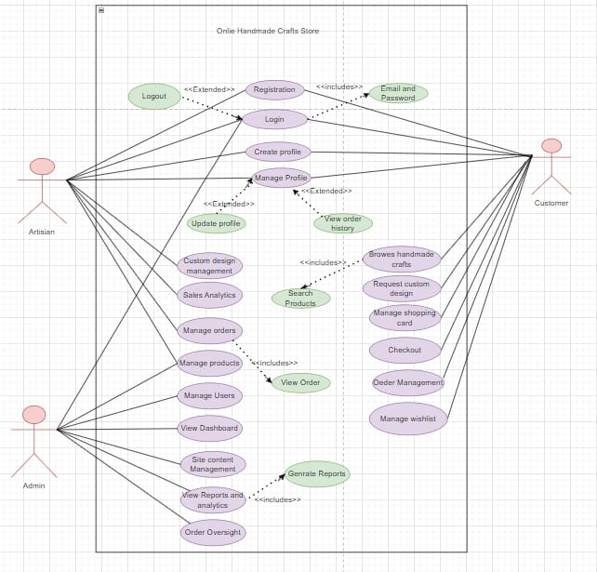

1.6.2 Usage Scenarios

Usage Scenario 1
Use Case Title | User Registration
Use Case Id | OHCS-01
Requirement Id | FR_1
Description: This use case is about user registration, where customers and artisans can create an account by filling out a signup form.
Pre-Conditions:
1. The customer or artisan has access to the Online Handmade Crafts Store website or mobile application..
Task Sequence for customer & Artisan |  | Exceptions
1. Customer clicks on the “Register” or “Sign Up” button. |  | 1. Customer enters invalid information.
2. System asks for necessary information, such as name, address, phone number, and email address.
3. Customer fills out the signup form with the required information.
4. System validates the information and creates an error if the information is invalid.
Post Conditions:
- A new account is successfully created for the customer or artisan.
- Customer or artisan receives a confirmation email with their login credentials.
Authority: Customer, Artisan
Author:BC210415321

Usage scenario 2
Use Case Title | Profile Creation
Use Case Id | OHCS-02
Requirement Id | FR_2
Description:This use case is about profile creation, where customers and artisans can create detailed profiles.
Pre-Conditions:
- The customer or artisan has a registered account on the Online Handmade Crafts Store website or mobile application.
Task sequence |  | Exceptions
1. Customer or artisan clicks on the “Create Profile” button. |  | 1. Customer or artisan enters invalid information.
2. System asks for necessary information, such as name, address, contact number, and desired handmade crafts categories (for customers) or basic artisan details, professional diplomas/training, qualifications, artisan experience, and facility pictures (for artisans).
3. Customer or artisan fills out the profile form with the required information.
4. System validates the information and creates an error if the information is invalid.
Post Conditions:
- A detailed profile is successfully created for the customer or artisan.
- Customer or artisan can view and edit their profile information.
Authority: Customer, Artisan
Author: BC210415321

Usage scenario 3

Use Case Title | User Login
Use Case Id | OHCS-03
Requirement Id | FR_3
Description: This use case is about user login, where users can log in with a username and password, and reset their password if needed..
Pre-Conditions:
- The user has a registered account on the Online Handmade Crafts Store website or mobile application.
Task Sequence |  | Exceptions
1. User clicks on the “Login” button. |  | 1. User enters incorrect username or password.
2. System asks for username and password.
3. User enters their username and password.
4. System validates the username and password and grants access if correct |  | 2. User clicks on “I forgot my password” and receives a password reset link to their verified email address.
Post Conditions:
- 1. User is successfully logged in to their account.
- 2. User can reset their password using the password reset link.
Authority: Customer, Artisan
Author: BC210415321

Usage scenario 4
Use Case Title | Browse Handmade Crafts
Use Case Id | OHCS-04
Requirement Id | FR_4
Description: This use case is about browsing handmade crafts, where customers can browse handmade crafts by categories, artisans, or search functionality.
Pre-Conditions:
- The customer is logged in to their account on the Online Handmade Crafts Store website or mobile application.
Task Sequence |  | Exceptions
1. Customer clicks on the “Browse” button. |  | 1. Customer enters invalid search criteria.
2. System displays a list of handmade crafts with filtering options. |  | 2. No handmade crafts match the search criteria.
3. Customer selects filtering options (price range, rating, availability) and searches for handmade crafts.
4. System displays the search results with detailed product information.
Post Conditions:
- 1. Customer can view a list of handmade crafts that match their search criteria.
- 2. Customer can filter the search results by price range, rating, and availability.
Authority: Customer
Author:BC210415321

Usage scenario 5
Use Case Title | Product Pages
Use Case Id | OHCS-05
Requirement Id | FR_5
Description: This use case is about viewing product pages, where customers can view detailed product information, including images, descriptions, price, and available stock.
Pre-Conditions:
- The customer is logged in to their account on the Online Handmade Crafts Store website or mobile application.
- The customer has selected a handmade craft to view.
Task Sequence |  | Exceptions
1. Customer clicks on the selected handmade craft. |  | 1. Product information is not available.
2. System displays the product page with detailed product information.
3. Customer views the product images, descriptions, price, and available stock. |  | 2. User reviews and ratings are not available.
4. System displays user reviews and ratings for the product.
Post Conditions:
- Customer can view detailed product information, including images, descriptions, price, and available stock.
- Customer can view user reviews and ratings for the product.
Authority: Customer
Author:BC210415321

Usage scenario 6
Use Case Title | Custom Design Requests
Use Case Id | OHCS-06
Requirement Id | FR_6
Description:This use case is about custom design requests, where customers can request custom-made products by filling out a form with design specifications.
Pre-conditions:
- 1. The customer is logged in to their account on the Online Handmade Crafts Store website or mobile application.
Task sequence |  | Exceptions
1. Customer clicks on the “Custom Design Request” button. |  | 1. Customer enters invalid design specifications.
2. System displays a form for the customer to fill out with design specifications. |  | 2. Artisan is not available to fulfill the custom design request.
3. Customer fills out the form and submits it.
4. System sends the custom design request to the selected artisan.
Post Conditions:
- Custom design request is successfully sent to the artisan.
- Customer can communicate directly with the artisan regarding customizations.
Authority: Customer
Author:BC210415321

Usage scenario 7
Use Case Title | Shopping Cart and Checkout
Use Case Id | OHCS-07
Requirement Id | FR_7
Description: This use case is about shopping cart and checkout, where customers can add products to the cart, modify the quantity, and complete a secure checkout process.
Pre-Conditions:
- The customer is logged in to their account on the Online Handmade Crafts Store website or mobile application.
- The customer has selected products to purchase.
Task Sequence |  | Exceptions
1. Customer clicks on the “Add to Cart” button. |  | 1. Customer enters invalid payment information.
2. System adds the selected products to the shopping cart.
3. Customer modifies the quantity of products in the shopping cart. |  | 2. Payment processing fails.
4. System updates the shopping cart with the modified quantity.
Post Conditions:
- 1. Customer completes a secure checkout process.
- 2. Order summary and confirmation are provided.
Authority: Customer
Author: BC210415321

Usage scenario 8
Use Case Title | Order Tracking
Use Case Id | OHCS-08
Requirement Id | FR_8
Description: This use case is about order tracking, where customers can view order status and receive notifications for order updates.
Pre-Conditions:
- The customer is logged in to their account on the Online Handmade Crafts Store website or mobile application.
- The customer has placed an order.
Task Sequence |  | Exceptions
1. Customer clicks on the “Order Tracking” button. |  | 1. Order status is not available.
2. System displays the order status (processing, shipped, delivered). |  | 2. Notification fails to send.
3. System sends notifications for order updates.
4. Customer views the order status and updates.
Post Conditions:
- Customer can view the order status.
- Customer receives notifications for order updates.
Authority: Customer
Author: BC210415321

Usage scenario 9
Use Case Title | Wishlist
Use Case Id | OHCS-09
Requirement Id | FR_9
Description: This use case is about wishlist, where customers can save favorite products for future purchases.
Pre-Conditions:
- The customer is logged in to their account on the Online Handmade Crafts Store website or mobile application.
Task sequence |  | Exceptions
1. Customer clicks on the “Add to Wishlist” button. |  | 1. Product is not available.
2. System adds the selected product to the wishlist. |  | 2. Wishlist is full.
3. Customer views the wishlist.
4. System allows customer to remove products from the wishlist.
Post Conditions:
- Customer can view and manage their wishlist.
- Customer can add and remove products from the wishlist.
Authority: Customer
Author:BC210415321

Usage scenario 10
Use Case Title | User Profile Management
Use Case Id | OHCS-10
Requirement Id | FR_10
Description: This use case is about user profile management, where customers can manage personal details, view past orders, and manage saved payment methods.
Pre-Conditions:
- The customer is logged in to their account on the Online Handmade Crafts Store website or mobile application.
Task sequence |  | Exceptions
1. Customer clicks on the “My Account” button. |  | 1. Customer enters invalid information.
2. System displays the customer’s profile information. |  | 2. Order history is not available.
3. Customer updates personal details (name, email, address).
4. System allows customer to view past orders and order history.
Post Conditions:
- Customer can view and update their profile information.
- Customer can view past orders and order history.
- Customer can manage saved payment methods.
Authority: Customer
Author: BC210415321

Usage scenario 11
Use Case Title | Artisan (Seller) Features
Use Case Id | OHCS-11
Requirement Id | FR_11
Description: This use case is about artisan (seller) features, where artisans can manage their products, orders, and custom design requests.
Pre-conditions:
- The artisan is logged in to their account on the Online Handmade Crafts Store website or mobile application.
Task Sequence |  | Exceptions
1. Artisan clicks on the “Product Management” button to upload product images, descriptions, and pricing, set inventory levels, and update availability. |  | 1. Artisan enters invalid product information.
2. Artisan clicks on the “Order Management” button to view and manage incoming orders, and update order status. |  | 2. Order status update fails.
3. Artisan clicks on the “Custom Design Management” button to review customer design requests, communicate with customers, provide price estimates, and delivery timelines for custom orders. |  | 3. Custom design request details are not available.
4. System allows the artisan to perform the selected action.
Post Conditions:
- 1. Artisan can successfully manage their products, orders, and custom design requests.
- 2. System updates the artisan’s product, order, and custom design request information.
Authority:Artisan
Author:BC210415321

Usage scenario 12
Use Case Title | Sales Reports
Use Case Id | OHCS-12
Requirement Id | FR_12
Description: This use case is about sales reports, where artisans can view sales analytics.
Pre-Conditions:

- The artisan is logged in to their account on the Online Handmade Crafts Store website or mobile application.
Task Sequence |  | Exceptions
1. Artisan clicks on the “Sales Reports” button. |  | 1. Sales reports are not available.
2. System displays sales analytics, including total sales, top-selling products, and customer feedback. |  | 2. Exporting sales reports fails.
3. Artisan views and analyzes the sales reports.
4. System allows the artisan to export the sales reports.
Post Conditions:
- 1. Artisan can view and analyze sales reports.
- 2. Artisan can export sales reports.
Authority: Artisan
Author: BC210415321

1Usage scenario 13
Use Case Title | Profile Management
Use Case Id | OHCS-13
Requirement Id | FR_13
Description: This use case is about profile management, where artisans can manage their artisan bio, product details, and contact information.
Pre-conditions:
- The artisan is logged in to their account on the Online Handmade Crafts Store website or mobile application.
Task Sequence |  | Exceptions
1. Artisan clicks on the “Profile” button. |  | 1. Profile information is not available.
2. System displays the artisan’s profile information.
3. Artisan updates their artisan bio, product details, and contact information. |  | 2. Updating profile information fails.
4. System validates the updated profile information and creates an error if the information is invalid.
Post Conditions:
- Artisan can view and update their profile information.
- Artisan’s profile information is successfully updated.
Authority:Artisan
Author:BC210415321

Usage Scenario 14
Use Case Title | Admin Features
Use Case Id | OHCS-14
Requirement Id | FR_14
Description: This use case is about admin features, where administrators can manage various aspects of the Online Handmade Crafts Store website.
Pre-Conditions:
- The administrator is logged in to their account on the Online Handmade Crafts Store website.
Task Sequence |  | Exceptions
1. Administrator clicks on the “Dashboard” button to view an overview of website activity. |  | 1. Administrator enters invalid user information
2. Administrator clicks on the “User Management” button to manage customer and artisan accounts. |  | 2. Product listing is invalid.
3. Administrator clicks on the “Product Management” button to monitor and manage product listings.
4. Administrator clicks on the “Order Management” button to oversee orders and transactions. |  | 3. Order information is not available.
Post Conditions:
- 1. Administrator can successfully manage various aspects of the website.
- 2. Website activity is successfully monitored and managed.
Authority:Administrator
Author:BC210415321

1.7 Development Methodology

1.7.1 Chosen Methodology

My Adopted Methodology

I adopt VU Process Model to build the Interactive Learning Application. Its suits best for our application as it’s a combination of waterfall and spiral model. When combined these two models a VU Process model formed.

- VU process model having powerful acceptability.
- This model mostly enhances the quality of the application and reduces the risk and flawless.
- Testing is possible with model. As, VU Process Model allows making modifications at any stage of development processes.

Here is the diagram showing some phases of VU process model.

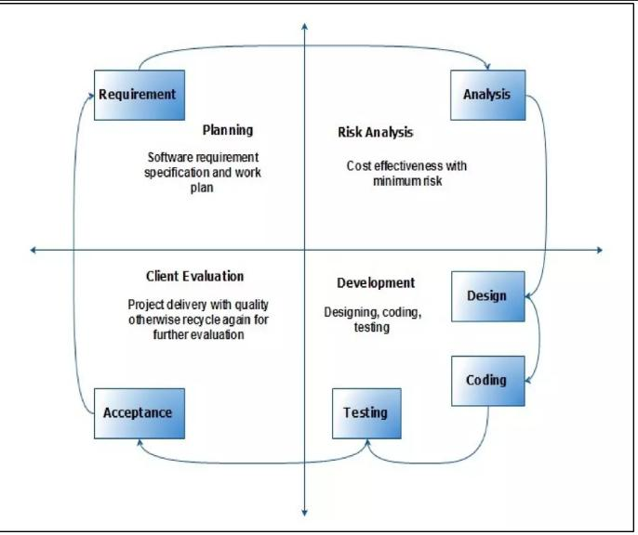
VU Process Model

1.7.2 Reasons for Chosen Methodology
Given below are some reasons for preferring VU Process Model for this system:
Selection Reasons:
- VU Process Model is sequential model with backward repetition.
- In VU Process Model all activities are performed in a sequence.
- VU Process Model is more concise and advanced model then waterfall model because we can go back at any stage of development which is not allowed in waterfall model.
- When we want repetition then we can choose VU Process Model.
- VU Process Model provides us facility to do correction at any stage.
- Whenever we want any betterment in our system then we can choose VU process model.
- This model is used when cost and risk evaluation is important.
- This methodology is also used when users are unsure of their requirement.
- It is also used when significant changes are expected.

1.7.2 Work Plan (Gantt Chart)

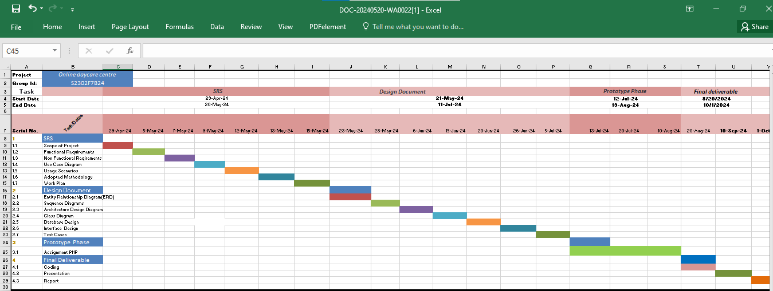

1.7.2 Project Schedule (Submission Calendar)

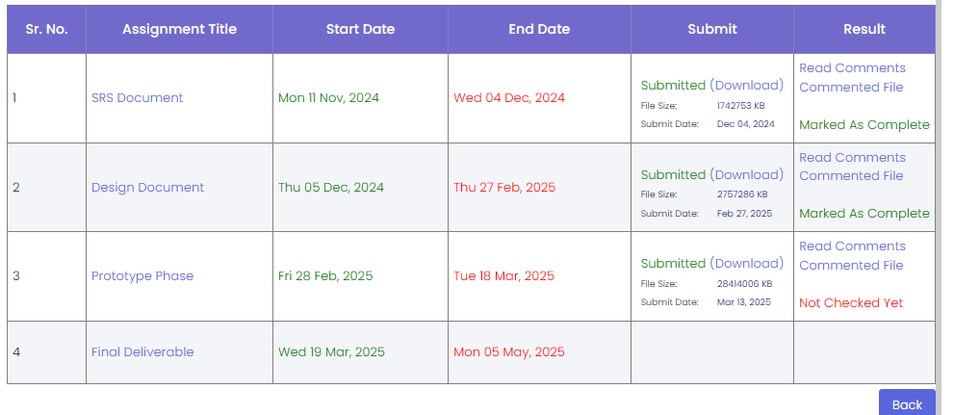

CHAPTER 2
Designing the Project

2.1 Introduction

The Online Handmade Crafts Store is an e-commerce platform designed to connect artisans with customers seeking unique, handmade products. This online marketplace aims to provide artisans with a digital storefront to showcase and sell their handmade crafts, while enabling customers to discover exclusive products and connect directly with artisans for custom orders. The platform will facilitate a seamless exchange between buyers and sellers, fostering a vibrant ecosystem for artisans to thrive and customers to enjoy distinctive, handcrafted items.
The design document describes and introduce the designing of the Project which includes the
- Entity Relationship diagram
- Sequence Diagram
- Architecture Design Diagram
- Class Diagrams
- Database Design
- Interface Design
- Test Cases
This design document provides a comprehensive overview of the various components crucial to the development of our software project. It serves as a blueprint for developers, testers, and stakeholders, ensuring that all aspects of the project are well-understood and meticulously planned.

2.2 purpose

- The purpose of design phase in software development is to provide the detail of the project that helps the users to understand the functionality of the system. This will help us to understand the scenario of the system. It also shows how to do and what to do.

- After reading this document we will be able to understand whole functionality in the form of graphics. This document will also use later during implementation, testing and coding.

2.3 scope
The scope of this design document encompasses the detailed planning and architectural framework necessary for the successful development of the software project. It includes the specification of system components, their interactions, and data models, providing a comprehensive guide for the entire development team.
Activities Used in This Design Document:
Different activities that are used in this document are briefly explained below:

- ERD (Entity Relationship Diagram):
This diagram represents the conceptual database model, depicting the entities, their attributes, and the relationships between them.
- Sequence Diagram:
This diagram shows the interactions between objects or actors in a sequential manner.
- Architecture Design Diagram:
This diagram outlines the high-level structure of the software system, highlighting the components/modules, their dependencies, and the interactions among them.
- Class Diagram:
This diagram showcases the static structure of the system, depicting the classes, their attributes, and the relationships between them.
- Database Design:
This section describes the design of the system’s database, including the tables, their attributes, the relationships, and the normalization techniques applied.
- Interface Design:
This section shows the design of the user wireframes, mockups, or prototypes. It showcases the layout, navigation and visual elements of the system’s interface.
- Test Cases:
This section outlines the test scenarios, test data, and expected results for various functionalities of the system.

2.4 definitions, acronyms and abbreviations
- ER (Entity Relationship)
- SRS (Software Requirement Specification)
- GUI ( Graphical User Interface)

2.5 Architectural Representation (Architecture Diagram)

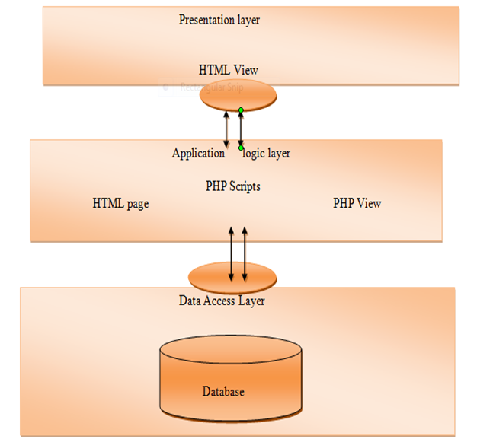

2.6 Dynamic Model: Sequence Diagrams

- Registration
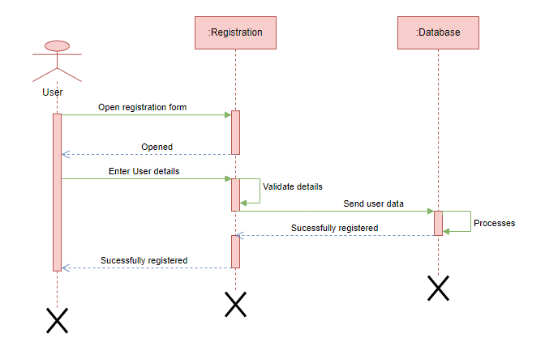

- Login
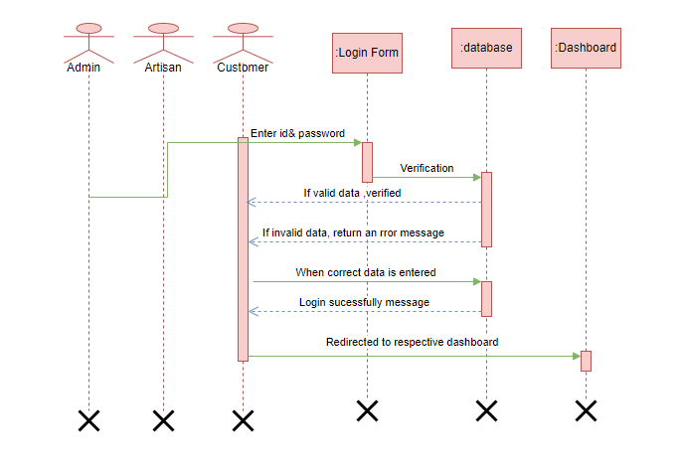

- Sequence diagram for Artisan’s Product, Inventory and order management

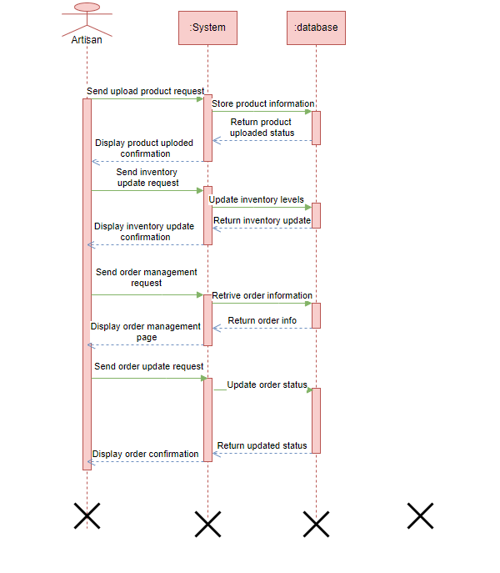

- Sequence diagram for Customer view product, add to cart, checkout, save to wishlist

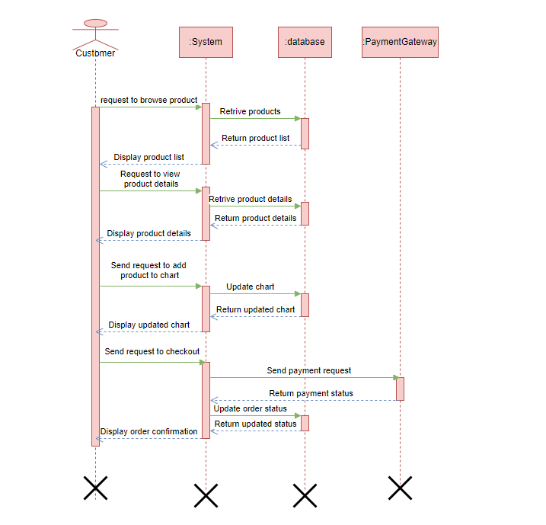

- Sequence diagram for Admin Manage user accounts, products, orders, view repots and analytics

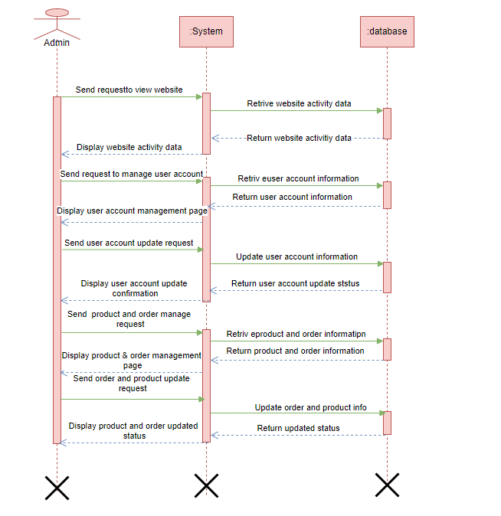

- Logout
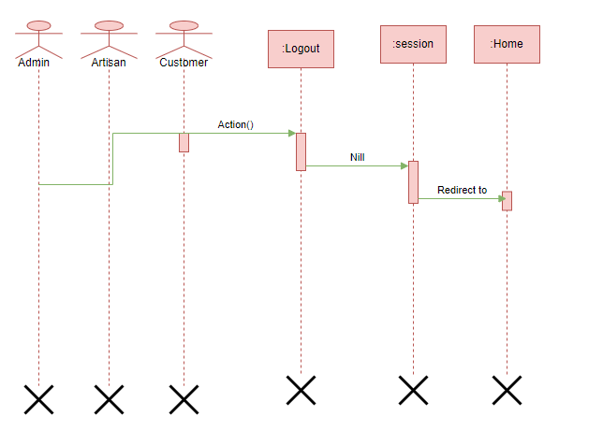

2.7 Object Model/Logical Model: Class Diagram

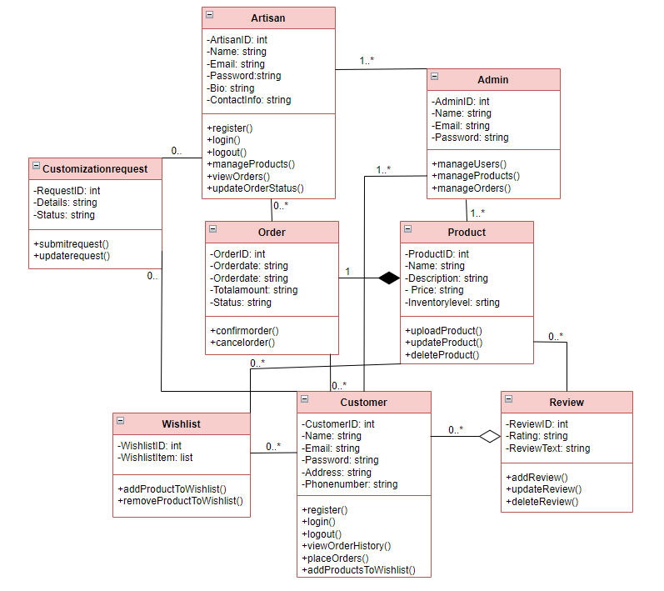

2.8 Database Model (Database Diagram)

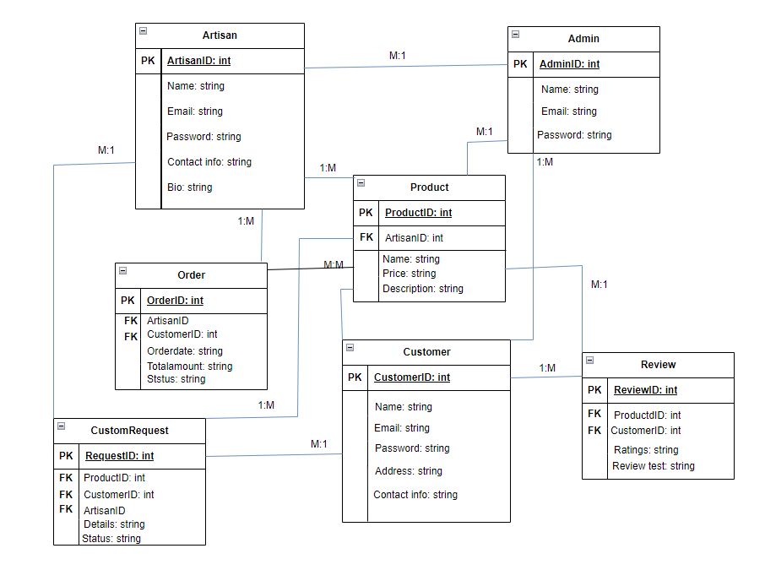

2.9 Graphical User Interfaces

User Interface (Register)

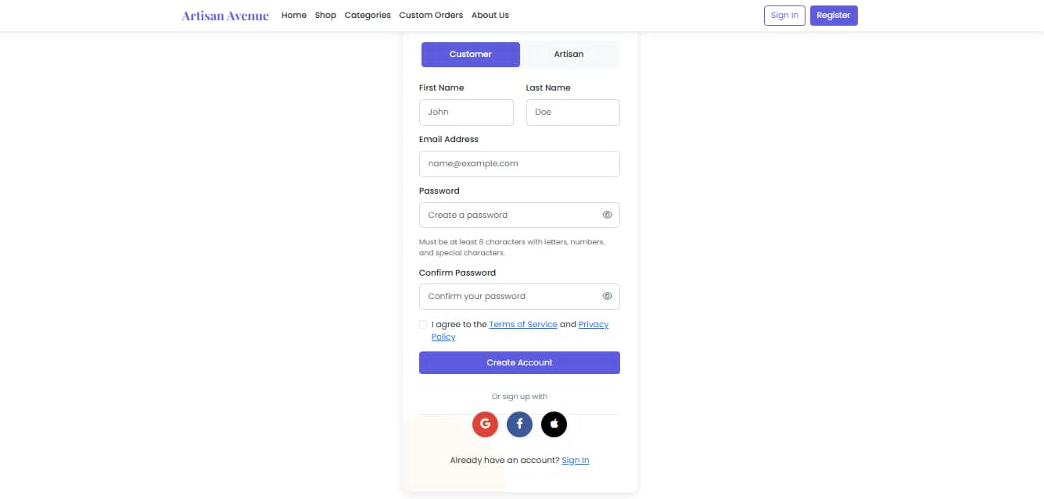
User Login

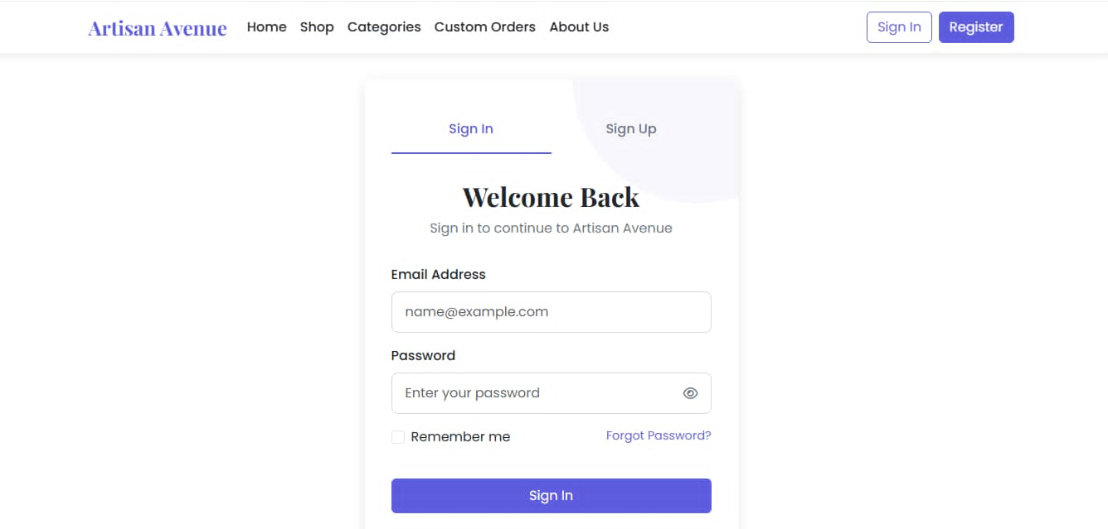

Home Page

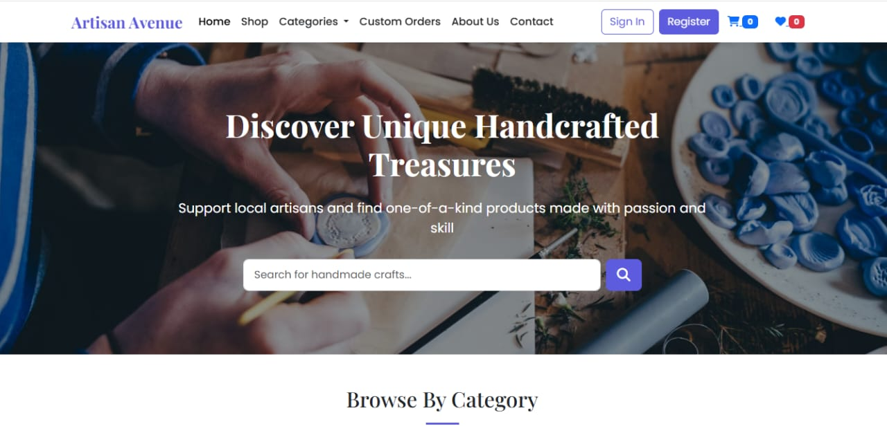

Admin Dashboard

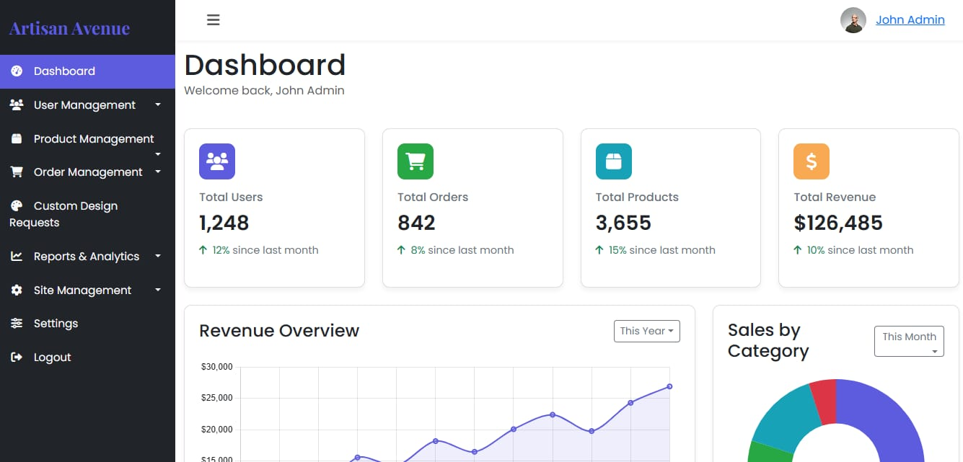

Artisan Dashboard

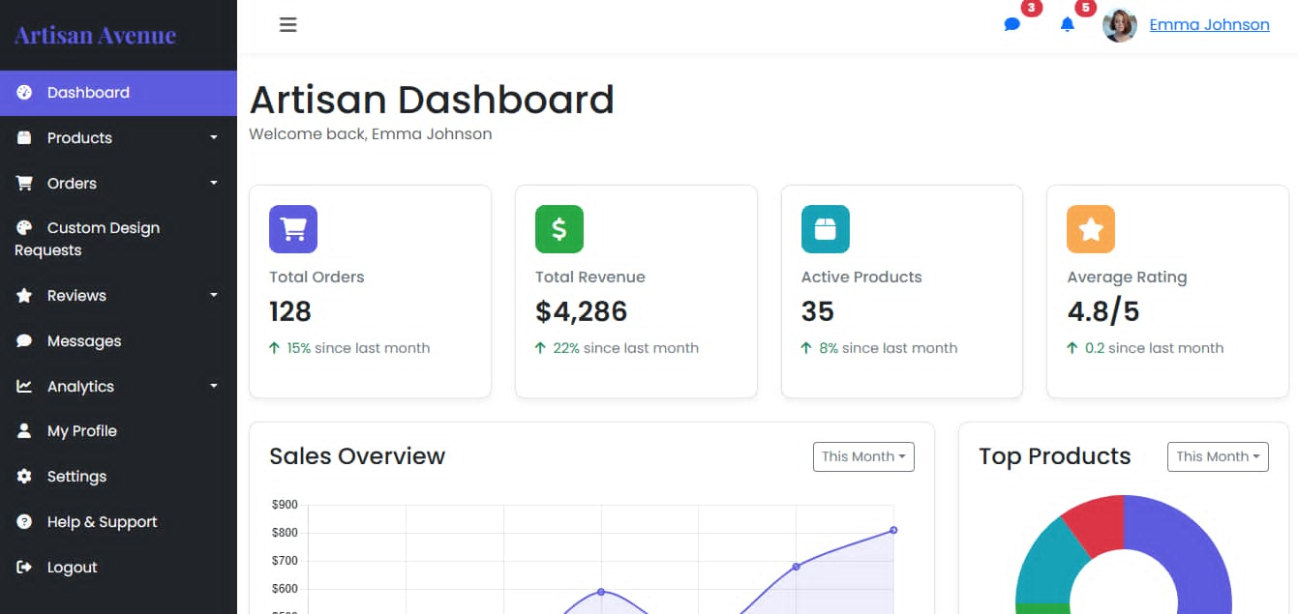

CHAPTER 3
Development

3.1 Development plan (Architecture Diagram)

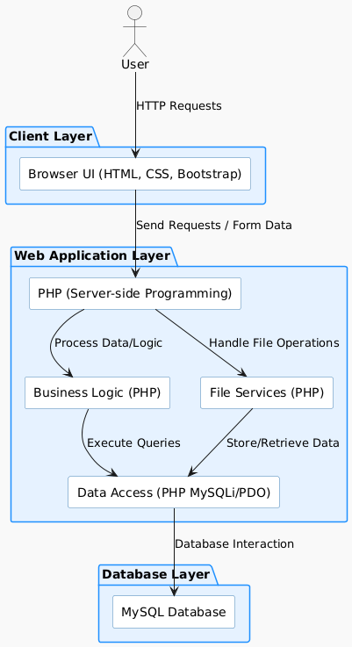

Languages:
HTML, CSS, Bootstrap (Front-end)
PHP (Server-side programming)
Server:
XAMPP — Web Application Server
Database:
MySQL (Backend)
Text Editor:
Visual Studio Code
Web Browser:
Internet Explorer, Chrome, Mozilla Firefox
Software:
Microsoft Package (MS Word, MS Project, MS Visio, MS PowerPoint)
Versions ( 2016 , 2016 , 2016 , 2016)

REFERENCES

BOOKS
- Handout CS504 – Software Engineering
- Handout CS304 – Object Oriented Programming
YOUTUBE
- Different YouTube Videos (e.g., Code With Harry, Appna College, Yahoo Baba, Technical Thapa, WP Academy)
WEBSITES
- Google : (https://www.google.com)
- W3Schools :( https://www.w3schools.com)
- Great Learning : (https://www.greatlearning.com)

APPENDIX

CHAPTER 1 | Gathering & Analyzing Phase
CHAPTER 2 | Designing the Project
CHAPTER 3 | Development

The End 😊

